Daffodil Institute of IT (DIIT)

Computer Science and Engineering

­

Md. Toufiq-Ul-Alam

Student, Department of CSE, Daffodil Institute of IT, Bangladesh

Email: toufiq180020@diit.edu.bd

Nusrat Jahan Surovi

Student, Department of CSE, Daffodil Institute of IT, Bangladesh

Email: toufiq180020@diit.edu.bd

Mizanur Rahman

Lecturer, Department of CSE, Daffodil Institute of IT, Bangladesh

Email: mizanur@diit.edu.bd

-----------------------------------------------------------------------------------------------------------------------------

**Article Information**

**Received: date**

**Accepted: date**

**Online Published: date**

**URL: <https://doi.org/10.5539/ibr.v14n2p1>**

**Paper ID:**

Correspondence to Jae Hwa Changinfolumi.jh@gmail.com

Cite this paper:



|  |  |
| --- | --- |
|  | **Scan the code to see the article** |

**Copyright**

Copyright for this article is retained by the author(s), with first publication rights granted to the journal. This is an open-access article distributed under the terms and conditions of the Creative Commons Attribution license (http://creativecommons.org/licenses/by/4.0/).

**Abstract:** *Emotion recognition using machine learning have plenty of applications in areas such as education, healthcare, marketing, and entertainment, and have the potential to improve human-computer interaction and communication. However, appropriate recognition of emotions remains a challenging task due to the complexity and inconstancy of human behavior, and ongoing research is needed to achieve the performance and robustness of machine learning models. Emotion recognition entangles the use of algorithms and statistical models to automatically acknowledge the patterns and features in visual and auditory data that fit specific emotional states and nonverbal behaviors. The process typically meets several steps, including data collection, feature extraction, model training, and model testing.*

**Keyword:** *ai;conv2d; detection; machine learning; opencv; python;*

1. INTRODUCTION

Emotion recognition using machine learning is a sensational and rapidly flourishing field that involves the development of algorithms and models to automatically understand human emotions and nonverbal behaviors from visual and auditory data. The technology field has numerous applications in a wide range, including education, healthcare, marketing, and entertainment, and has the potential to improve interaction and communication.

The ability to accurately recognize emotions and nonverbal behaviors has long been recognized as a crucial aspect of human communication and social interaction. However, traditional methods for assessing emotions and nonverbal behaviors, such as self-report questionnaires or human coding of behavior, can be time-consuming, costly, and subject to biases and errors.

In recent years, advances in machine learning, computer vision, and natural language processing have enabled the development of sophisticated algorithms and models that can analyze and interpret complex and diverse visual and auditory data to recognize emotions and nonverbal behaviors automatically. This technology has the potential to revolutionize how we interact with computers and other devices, making communication more natural, intuitive, and efficient.

However, accurate recognition of emotions and nonverbal behaviors using machine learning remains a challenging task due to the variability and complexity of human behavior, as well as the need to account for cultural and individual differences. Ongoing research and development are needed to improve the performance and robustness of machine learning models for emotion recognition and to address ethical and privacy concerns related to the use of such technology.

1. Background Study

2.1. Machine Learning

In machine learning, tasks are generally classified into broad categories. These categories are based on how learning is received or how feedback on the learning is given to the system developed

2.2. CNN

Convolutional Neural Networks are a special kind of multi-layer neural network. Like almost every other neural network they are trained with a version of the back-propagation algorithm. Where they differ is in the architecture. Convolutional Neural Networks are designed to recognize visual patterns directly from pixel images with minimal preprocessing. They can recognize patterns with extreme variability (such as handwritten characters), and with robustness to distortions and simple geometric transformations.

2.3. Perceptron

Perceptron is an algorithm for supervised learning of binary classifiers (functions that can decide whether an input, represented by a vector of numbers, belongs to some specific class or not). It is a type of linear classifier, i.e. a classification algorithm that makes its predictions based on a linear predictor function combining a set of weights with the feature vector. The algorithm allows for online learning, in that it processes elements in the training set one at a time.

The perceptron algorithm dates back to the late 1950s. Its first implementation, in custom hardware, was one of the first artificial neural networks to be produced.

2.4. Streamlit

In the rapidly evolving landscape of software development, creating user-friendly and interactive applications is a paramount goal. One tool that has gained remarkable traction in achieving this is Streamlit. Streamlit is an open-source Python library that empowers developers to effortlessly build web applications for data science and machine learning projects. In this chapter, we'll delve into the world of Streamlit, exploring its features, benefits, and the process of creating dynamic applications.

2.4. OpenCV

In the realm of computer vision, OpenCV stands as a cornerstone, empowering developers to unravel the visual world and imbue machines with the ability to perceive and understand. This chapter delves into the captivating landscape of OpenCV (Open Source Computer Vision Library), exploring its history, functionalities, and the remarkable transformations it brings to various industries.

**2.4. Hugging Face Transformer**

In the fast-paced domain of natural language processing (NLP) and machine learning, Hugging Face Transformers have emerged as a transformative force, reshaping the way we approach language understanding, generation, and translation. This chapter delves into the intricate world of Transformers, exploring their significance, capabilities, and the profound impact they've had on various applications across industries.

2.7. Data Augmentation

Data Augmentation is a process which increases the number of parameters of a dataset. It adds value to base data by adding information derived from internal and external sources within an enterprise.

1. Dataset

A data set is a collection of information organized as a stream of bytes in the logical record and block structures. The record format is determined by data set organization, recorded information styling, and other parameters. Most commonly a data set corresponds to the contents of a single database table, or a single statistical data matrix, where every column of the table represents a particular variable, and each row corresponds to a given member of the data set in question. The data set lists values for each of the variables, such as audio and video of an object, for each member of the data set.

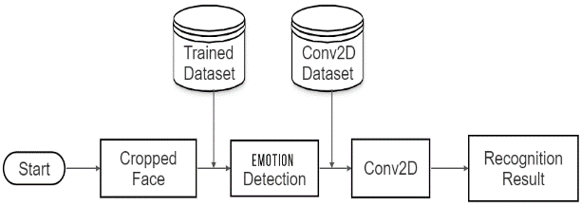

Level 3 Heading

The level 3 headings can have the font times new roman 10 with bold face. Capitalize each word except the connective words such as and, of, etc.

* + - 1. *Level 4 heading*

The level 4 headings can have the font times new roman 10 italic. Capitalize only the first word. All the section headings must be numbered according to the guidelines given in Section 2 of this document.

1. Implementation

Emotion recognition is a challenging and important task in computer vision and natural language processing. Being able to accurately identify emotions from both images and text can have numerous applications, including sentiment analysis, user experience enhancement, and mental health monitoring.

Our image-based emotion recognition model is based on Convolutional Neural Networks (Conv2D). We design a deep neural network architecture that takes images as input, passes them through several convolutional and pooling layers, and finally produces emotion predictions. We fine-tune the model using our preprocessed image dataset.

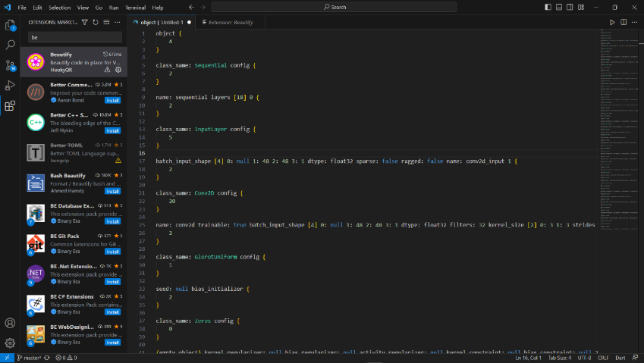

1. CONCLUSION

Emotion recognition using Conv2d and Data Augmentation is a promising approach for accurately and reliably recognizing emotions in real-time. With continued research and development, it has the potential to significantly improve our ability to understand and respond to human emotions in various settings.

1. ACKNOWLEDGEMENTS

Provide acknowledgement if any.

REFERENCES

1. Kipp, M., & Martin, J. C. (2009, September). Gesture and emotion: Can basic gestural form features discriminate emotions? In 2009 3rd international conference on affective computing and intelligent interaction and workshops (pp. 1-8). IEEE..
2. Castellano, G., Kessous, L., & Caridakis, G. (2008). Emotion recognition through multiple modalities: face, body gesture, speech. Affect and Emotion in Human-Computer Interaction: From Theory to Applications, 92-103.
3. Dael, N., Goudbeek, M., & Scherer, K. R. (2013). Perceived gesture dynamics in nonverbal expression of emotion. Perception, 42(6), 642-657.
4. De Stefani, E., & De Marco, D. (2019). Language, gesture, and emotional communication: An embodied view of social interaction. Frontiers in Psychology, 10, 2063.
5. Chen, H., Liu, X., Li, X., Shi, H., & Zhao, G. (2019, May). Analyze spontaneous gestures for emotional stress state recognition: A micro-gesture dataset and analysis with deep learning. In 2019 14th IEEE International Conference on Automatic Face & Gesture Recognition (FG 2019) (pp. 1-8). IEEE.
6. Hobson, R. P. (1986). The autistic child's appraisal of expressions of emotion: A further study. Journal of Child Psychology and Psychiatry, 27(5), 671-680.

**Authors Biography (Mandatory)**

**Md. Toufiq-Ul-Alam,** Student, Department of CSE, Daffodil Institute of IT.

E-mail: [toufiq180020@diit.edu.bd](mailto:toufiq180020@diit.edu.bd)

**Nusrat Jahan Surovi,** Student, Department of CSE, Daffodil Institute of IT.

E-mail: [nusrat180004@diit.edu.bd](mailto:nusrat180004@diit.edu.bd)

**Mizanur Rahman,** Lecturer, Department of CSE, Daffodil Institute of IT.

E-mail: [mizanur@diit.edu.bd](mailto:mizanur@diit.edu.bd)