INTERNSHIP REPORT
ON
An Overview of ARTISTI COLLECTION

Submitted to
Controller of Examinations
National University
Gazipur - 1704

Supervised by
Aminul Haque Russel
Lecturer BBA Program
Daffodil Institute of IT

Prepared by
Methun Bhattacharjee
Roll No: 1062451
Registration No: 1067197
Session: 2009-2010
Program: BBA
Major: Marketing
Daffodil Institute of IT
National University
……………………………………………………………………………...........
Date of Submission: April 8, 2015
LETTER OF TRANSMITTAL

April 8, 2015
Controller of Examinations
National University
Gazipur - 1704

Subject: Submission of Internship Report.

Dear Sir,
With due respect I am submitting my internship report on the topic named, an overview of ARTISTI COLLECTION. It’s my pleasure to inform you that I have already finished my internship in an organization named ARTISTI COLLECTION. It was undoubtedly an interesting opportunities to work on this assigned topic to enhance my knowledge in the practical field. I would like to give you thank for giving me this opportunities. The Internship program has given me the opportunities to explore one of the latest and unexplored areas in business in contest of Bangladesh and expand my knowledge there by. An internship report based on the practical experience & idea obtained during working marketing sector.
There for I sincerely hope that you will appreciate my effort and I shall be grateful if my report is accepted for the appropriate purpose.

Sincerely yours

-----------------------------
Methun Bhattacharjee
Roll No: 1062451
Reg No: 1067197
Session: 2009-2010
Program: BBA
Major in Marketing

CERTIFICATE OF APPROVAL

This is certify that Methun Bhattacharjee, a student of Bachelor of Business Administration (BBA), Daffodil Institute of Information Technology (DIIT) worked under my supervision during his internship placement at ARTISTI COLLECTION, UCEP Cheye Tower, 25 Shegun Bagicha, Dhaka-1000, Bangladesh on the topics an overview of ARTISTI COLLECTION. I am pleased to state that Methun Bhattacharjee worked hard in preparing this report and he has able to present a good picture of the concerned organization. The data and findings presented in the report seem to be authentic.

Methun Bhattacharjee possesses a good moral character and pleasing personality. I wish his all success.

-----------------------------
AMINUL HAQUE
Lecturer BBA Program
Daffodil Institute of IT

ACKNOWLEDGEMENT

All praise to God, and the merciful. Without his blessing and endorsement this report would not been accomplished. The successful complementation of this report might never be possible in without the help of some person whose inspiration and suggestion mind it happen.
I am grateful to Aminul Haque, Lecturer BBA Program, for providing me all sorts of facilities requested from time to time.

I am also grateful to Mohammed Shakhawat Hossain, Principal of Daffodil Institute of IT (DIIT) for providing me all sorts of facilities requested by me.

I am grateful to Lakkhan Chandra Robidas, Coordinator BBA Program; Daffodil Institute of IT (DIIT), for providing me all sorts Cooperation.

I am very grateful to Mr. Veranda Sing (Head of M/S) & Major A.N.M Shahidul Alam, Head of Admin & HR of ARTISTI collection for their cooperation & spontaneous help in data collection. I would also remain very much thankful to the entire person of ARTISTI collection.
Finally, I am grateful to all the employees of Daffodil Institute of IT (DIIT) of Kalabagan Branch as they helped me out in explaining the work practice and accompanied me through my period. I also express my sincere gratitude to all those who participate the report. Most of them were very busy employer of ARTISTI collection.

EXECUTIVE SUMMARY
Textile retail products play a vital role in meeting human basic needs. We often only consider textiles to be the clothes we wear. Obviously, the clothing industry is where the majority of textiles are produced and used. However, textiles are also important in all aspects of our lives from birth to death. The technological advances of textiles in various industries do not always get recognized as they do in the clothing industry. ARTISTI is one of the biggest retail textile firms in the Bangladesh.
This is a descriptive type of study. For this report I collect the information from many sources like primary & secondary sources which include my personal observation, company’s annual report, and official web site etc.
In chapter one, the report will describe the objectives, methodology & limitation of the study. In chapter two, I will describe the organizational profile. Organizational profile basically focused on ARTISTI collection’s historical background, mission, vision, logo and management hierarchy, key of success.
In chapter three, I will describe the Branding criteria of ARTISTI collection and overall market scenario. In chapter four, the report will describe SWOT Analysis. SWOT Analysis refers to the strength, weakness, opportunities & threats of ARTISTI collection.
In chapter five, the report pointed out some findings on the basis of SWOT analysis. In this chapter I will describe some recommendations. Recommendations include that they have to motivating all the employees to giving the best service to their all honorable customers. ARTISTI collection is one of the best names in the retail business sector of Bangladesh.

Table of Contents
NAME |  | Page No
Introductory Part | Letter of Transmittal
 | Certificate of Approval
 | Acknowledgement
 | Executive Summary
 | List of Acronyms
 | List of Tables
 | List of Figures
CHAPTER – 01 | Introduction
 | 1.1 Origin of the study
 | 1.2 Purpose of the study
 | 1.3 Objective of the study
 | 1.4 Methodology of the study
 | 1.5 Limitations of the study
CHAPTER – 02 | Organizational Overview
 | 2.1 About ARTISTI collection
 | 2.2 History of ARTISTI collection
 | 2.3 Mission
 | 2.4 Vision
 | 2.5 Logo
 | 2.6 Organogram of ARTISTI collection
 | 2.7 Key of success
CHAPTER – 03 | Branding and Market Scenario
 | Branding of ARTISTI collection
 | 3.1 Branding
 | 3.2 Branding Benefits
 | 3.3Brand values of ARTISTI collection
 | 3.4 The way ARTISTI follow for Successful branding
 | 3.5 Branding in Valentine promotion 2015
 | 3.6 Master art work
 | 3.7 All the billboards
 | 3.8 Sponsorship
 | 3.9 Using product for branding
 | 3.10 Using their exclusive outlet for indoor branding
 | 3.11 Branding by visual merchandising
CHAPTER – 04 | SWOT Analysis
 | 4.1 Strength
 | 4.2 Weakness
 | 4.3 Opportunities
 | 4.4 Threats
CHAPTER - 05 | Findings, Recommendations & Conclusion
 | 5.1 Findings
 | 5.2 Recommendations
 | 5.3 Conclusion
 | Bibliography

Introduction

1.1 Origin of the Study:
In today’s world only academic education does make a student perfect to become competitive with the corporate & Global business world. By doing an internship program, a student can get the opportunity to learn facing about real business world. Internship is highly needed to gain idea knowledge and experience. I am a BBA student of Daffodil Institute of Information Technology (DIIT) one of the reputed Institute (Under National University) in Bangladesh. It has designed its curriculum of the BBA Program such a way that the international standard graduates will be produced. After completing my 117 Credit hours I need to go for further professional experience through Internship program in ARTISTI COLLECTION. This organization has created a positive image to the customer’s mind by providing better service.
As a BBA Internee I have tried to maintain the pace with the competitive business environment on official Activities, Culture, Philosophy, and Norms & Styles. It should be reflect the best at any field of my Professional life. I acquired idea about real business and corporate world.
1.2 Objectives of the Study:
In retail business ARTISTI COLLECTION is one of the reputed Brand in Bangladesh write now & also one of the big organization of our economy.
1.2.1 General objectives of the Study:
The main objective of this study is to fulfill the partial requirement of BBA program under National University. Also, to apply the theoretical knowledge in the practical field.
1.2.2 Specific objectives of the Study:
Therefore, specifically other purposes of our study are as follows:
- To present an overview of ARTISTI COLLECTION
- To analyzing the position in ARTISTI COLLECTION in the retail textile business of Bangladesh.
- To identify the services quality they provide to the customer.
- To find their existing position and future opportunities.
- To identify their Problems.
- To evaluate the Brand image.
1.3 Methodology of the Study:
This is a Descriptive type of Study. For preparing this report data have been collected from both primary and secondary sources.
Primary Sources:
- Face to face conversation with the officers and stuffs of the company.
- Official documents which one is not publicly available.
Secondary Sources:
- Annual report of ARTISTI COLLECTION
- Official website of ARTISTI COLLECTION

1.4 Scope of the Study:
I have some scope and opportunities to collect the data for the report. For these I can collect very important data and information. I can collect it from the site, ARTISTI COLLECTION Office, etc. From the supporting organizations, I collect my desire information according from the visitor’s interview, employee interview, and organizations collecting many important data, information & graphical representation. From my workplace I got many help from reserve reports & relevant personnel. But the scope of this report was limited to the investigation, observance and practices the activities during my internship period.

1.5 Rationale of the Study:

As a student of a faculty of business studies, it is helpful to gain the practical knowledge about an organization and its overall activities. By doing this kind of activities, we can enrich our practical knowledge .With the application of acquired knowledge we will be able to develop ourselves and compete globally. So we can say that the rationale of this is comprehensive. Some rationale points are given bellows;
- Have an idea about the Retail Textile business in the Bangladesh.
- Investigate the overall functions of the organization.
- Understand the recent trend & practices in ARTISTI COLLECTION.
- Management System of the ARTISTI COLLECTION.
  - Limitations of the study:

- Duration of the internship program is not so enough to realize the proper scenario.
- Due to some legal obligation the organization is not providing sensitive information.
- Lack of experience in research work of mine.
- The employees are too busy with their jobs so they give me a few times to consult with them.

Organizational Overview

2.1 History of ARTISTI COLLECTION:

Eighteen years ago the creation of ARTISTI was just an ambitious dream. The dream was to establish a company that would have the strength, capacity and business acumen to stand on equal footing with the big names of ready-made apparels.

Today, eighteen years later the pipe dream has turned into an overwhelming reality. ARTISTI has pioneered the concept of fashion clothing in Bangladesh while the ready-made clothing industry of the country was busy in fulfilling the demands of western world.

ARTISTI produces apparel from own factories. The factories have a responsive management team with adequate international marketing concept. The team is well aware of the international fashion trends, concepts & customer requirements. Emphasize is given on global fashion scenario in order to give the products a real world-class ranking.

ARTISTI was established with a vision to fulfill the fashion needs of the aristocrats. Thus, for last about eighteen years ARTISTI could stalwartly satisfy the needs with its Incontestable Quality of raw materials i.e. fabrics, accessories and manufacturing, multiplicity in products, infrequent designs, grand showrooms/outlets, extremely polite and motivated sales staffs supported by a strong Marketing & Sales Team and a top-class Design Studio (DS).

2.2 Our Vision:

ARTISTI strongly feels that, it is established with a vision to fulfill the fashion needs of the aristocrats & to be a renowned Brand in Internationally.

2.3 Our Vision:

Following are the Mission of ARTISTI COLLECTION:

- Our mission is to create a different trend in the retail Industry.
- Our mission is to create a best visual merchandising in the fashion outfit.
- Our mission has to create a best sales team in the retail industry that will make’s ARTISTI different from others.
2.4 Fundamental Ethics of ARTISTI COLLECTION:

In retail business ARTISTI is one of the reputed Brands in Bangladesh write now. ARTISTI never compromised with TWO things, those are: firstly, the Design, and secondly, the Quality. ARTISTI produces fashion wears with the world best raw materials (fabrics & accessories) following the latest trends of the fashion. Every pieces of product is the result of finer craftsmanship personally filtered through its Managing Director Mr. Tariqur Rahman (Milan) who has tremendous knowledge on the world fashion trends with charismatic and unparalleled aesthetic sense of design development. To keep the track record steady and to achieve a constantly up-trend graph the Design Studio must follow a guideline to avoid any uncertainty.

Thus, for last about 18 years ARTISTI could stalwartly satisfy the needs with its Incontestable Quality (fabrics & preparation/manufacturing), Multiplicity in Products, Infrequent Designs, Grand Showrooms/Outlets, extremely polite and motivated Sales Staffs supported by a strong Marketing & Sales team and a top-class Design Studio (DS).

2.5 Key Success of ARTISTI COLLECTION:

There are some key of success sales which accelerate the mood of sales maximization. Milk vita gets this benefit from the following factors effectively-
- Good will
- Brand image
- Quality Product
- Knowing the customers need
- Certified performance & safety
- Service standards
- International value
- Sound marketing

2.6 Organogram of ARTISTI COLLECTION:
MD
Director
COO
Head of Administrative & HR
Manager
Finance & Accounts
Manager Marketing & Sales
Manager Research & Development
Assistant Manager
Admin. & HR

Asst. Manager
Finance & Accounts

Asst. Manager Marketing & Sales

Graphic Designer

Figure: Management Hierarchy
2.7 Logo of ARTISTI COLLECTION:
2.8 Departments of ARTISTI COLLECTION:
ARTISTI COLLECTION has the following functioning departments those are always work for providing quality full products and better services for their customers.
- HR Department
- Finance & accounts department
- Marketing & sales department
- Merchandiser department
- Research and Development Department
2.8.1 Activities of HR Department:
An efficiently run human resources department can provide your organization with structure and the ability to meet business needs through managing your company's most valuable resources -- its employees. There are several HR disciplines, or areas, but HR practitioners in each discipline may perform more than one of the more than six essential functions. In small businesses without a dedicated HR department, it's possible to achieve the same level of efficiency and workforce management through outsourcing HR functions or joining a professional employer organization.
Recruitment: The success of recruiters and employment specialists generally is measured by the number of positions they fill and the time it takes to fill those positions. Recruiters who work in-house -- as opposed to companies that provide recruiting and staffing services –ARTISTI recruitment team play a key role in developing the employer's workforce. They advertise job postings, source candidates, screen applicants, conduct preliminary interviews and coordinate hiring efforts with managers responsible for making the final selection of candidates.
Safety: Workplace safety is an important factor. Under the Occupational Safety and Health Act of 1989, employers have an obligation to provide a safe working environment for employees. One of the main functions of ARTISTIHR team is to support workplace safety training and maintain federally mandated logs for workplace injury and fatality reporting. In addition, HR safety and risk specialists often work closely with HR benefits specialists to manage the company's workers compensation issues. HR department of ARTISTI always trained all the employees regarding safety issues.
Employee relations: Relations between all the employees is very important. ARTISTI has some HR specialists who’s are responsible to build up a good relation among all the employees.
Compensation and benefit: Like employee and labor relations, the compensation and benefits functions of ARTISTI HR often can be handled by one HR specialist with dual expertise. On the compensation side, the HR functions include setting compensation structures and evaluating competitive pay practices. A comp and benefits specialist also may negotiate group health coverage rates with insurers and coordinate activities with the retirement savings fund administrator. Payroll can be a component of the compensation and benefits section of HR; however, in many cases, employers outsource such administrative functions as payroll.
Training and development: ARTISTI always has given priority to training. ARTISTI has some special trainer in every department. And they also taking information from market & developed various systems which are suitable for them.

2.8.2 Activities of Marketing & sales department:
Sales and marketing team has a substantial influence on the profitability of the business. You have to define roles that reflect the strengths of your products and assign responsibilities for achieving the sales performance required by the company. When your marketing strategy builds on the roles taken on by the members of your team, they can set achievable targets and take responsibility for meeting their objectives.
- Recruitment (sales related all the employees): ARTISTI marketing & sales team always taking part in recruitment when a sales related recruitment has been occurred & the manager of marketing and sales department is fully responsible for that.
2. Listening to customer needs: To establish a marketing strategy, it’s necessary to get closer to the clients and listen in order to find out what their needs are. It’s a marketing department task, to plan the necessary means for receiving customer feedback:
- Company Internal Channels: ARTISTI marketing and sales team Create surveys or capture information of the sales team and customer support (departments closest to the customer) that may be relevant to enhancing or redirecting the marketing strategies in the future.
- Channels outside the company: Perform searches and create actions in social networks that help to better understand the needs of users, in order to convert them into customers.

3. Track trends and monitor competition: It’s important to know the position of the company with respect to the market and the competition. That’s why from marketing, ARTISTI marketing and sales team watch the competition to learn what they do best or to identify their mistakes in order to avoid falling into them.
4. Innovate: ARTISTI believed that, Customers need to be surprised, and every day, given the higher offer, they are more demanding with this. The marketing department should work on new promotions, affiliate programs, customer retention techniques, improvements in the conversion of their messages and actions. It’s not a matter of inventing entirely different disruptive actions; you’ll find innovation in the small details and in the continuous improvement.
- Manage marketing Budget: Like any other department, the marketing department should be able to plan its budget for the next year’s activities, stretching it in order to make the most of it.
- Define strategic marketing plans: The most cost-effective strategies are those that are planned for the long term. To do so, you must draft a document setting out the objectives to be achieved in the following months; the actions that are to be undertaken; the strengths of the company; the competition; the target markets. In addition, these strategic plans must also be aligned both with the strategic plan of the company and with other departments’ plans.

2.8.3 Activities of Finance & Accounts Department:
At the base level, ARTISTI finance department will be responsible for all the day to day transactional accounting for the business. This will include the tracking of all transactions and the management of any government reporting. In very small owner-managed businesses this role is often filled by a family member with accounting experience. An outside accounting firm is usually used for annual financial statements and returns. In larger organizations this role will extend right through to preparing the financial statements with an external auditor engaged for assurance purpose.
- Preparation of financial statements,
- financial reporting,
- Ratio Analysis, Monthly management reporting,
- Dealing with Bank and others financial Institutes of all SBUs,
- L/C costing & L/C closing (Export & Import),
- Costing of process and finished goods,
- Bank Reconciliation Statements,
- Interest calculation of Loan and adjustment,
- Budget & Budgetary Control,
- Taxation & VAT matters, necessary schedule, voucher, evidence, supporting etc.
- Analysis of variances relating of financial matters.
2.8.4 Activities of Merchandise Department:
Garment merchandising is an intricate and detail oriented job. If it can be done properly can be very rewarding. On the country, if it is done with lack of knowledge, insufficient skill and thoroughness, it can be destructive.

- Development & costing
- Order confirmation
- Sampling
- Bulk fabric
- Bulk trim
- Embellishment
- Filing & correspondence
- Meeting

2.8.5 Activities of R&D Department:
A company's research and development department plays an integral role in the life cycle of a product. While the department usually is separate from sales, production and other divisions, the functions of these areas are related and often require collaboration. A thorough understanding of the functions of the research and development department allows you to maximize those duties at your small business, even if you don't have a big department.
- New product research
- New product development
- Existing product updates
- Quality checks
- Innovation

CHAPTER - 3

Branding and Market Scenario

3.1 Branding:
The process involved in creating a unique name and image for a product in the consumers' mind, mainly through advertising campaigns with a consistent theme. Branding aims to establish a significant and differentiated presence in the market that attracts and retains loyal customers.

3.2 Benefits of Branding:
Your brand should tell your customers exactly what to expect from you. Deliver on your promises and they will come back again and again. How often have you gone to a familiar restaurant chain because you know what's on the menu, what it will taste like and how much it will set you back? It's the same for your customers.
But a good brand identity will also attract new customers by stressing the differences between you and competitors. This is critical if you are in a highly competitive or fast moving market where it is difficult to differentiate yourself on product features alone.
The power of a strong brand is such that it can lift a single firm or product above others to become something truly memorable. Think of vacuum cleaners and you think of Hoover; think of MP3 players and iPod will doubtless spring to mind.

3.3 Brand values of ARTISTI:
Before you can develop your brand identity, you will have to understand what the core values of your business are, what your business mission is and how you differ from the competition.
You must also be sure that what you want to tell your customers about your business and your offer matches what your target customer segments want and what you actually deliver. It's no use developing a premium brand if your target market just wants value for money, for example; and a brand based on friendly service will not survive long if your staffs are unhelpful. ARTISTI knows about their target customers to knowing that, they provide their service & product like that way & do the effective branding, offer their customers a personality that suits their customers because they knows their brand value in retail market.
ARTISTI was very confident about their product line & the quality of the product so they always said that it’s a “value for money”
3.4 Promotional Events of ARTISTI COLLECTION:
ARTISTI strongly believed that, branding is very important to become a renowned brand internationally & also ARTISTI knows their brand value in market. ARTISTI basically given priority to their all promotional event for Branding. All promotional events:
- Valentine Promotion
- Baishakhi Promotion
- Mega sale
- Eidul Adha
- Eidul fitre
- Winter Promotion
3.5 The techniques ARTISTI Follow for successful Branding:

- Master art work
- Billboard
- Sponsorship
- Using Product for branding
- Branding by Visual Merchandising
- Using their exclusive outlet for Indoor Branding
- Leaflet,
- Stand banner & paper add

3.5.1 Master art work.
This is the master artwork of ARTISTI for valentine 2015.Using this artwork in shopping bag Leaflet, Billboard, Stand banner & paper add ARTISTI complete their branding successfully.
3.5.2 Bill boards:
Bill Boards is one of the best Promotional items which can affect people’s mind. Through the billboard brand can create position on people mind which is very effective thing for branding. ARTISTI always utilize their bill boards in a proper way & every message has changed event wise.
3.5.3 Sponsorship:
ARTISTI will always participate willingly in a different social program & activities to promote their brand & also their product.

3.5.4 Using Product for branding

3.5.5 Branding by Visual Merchandising
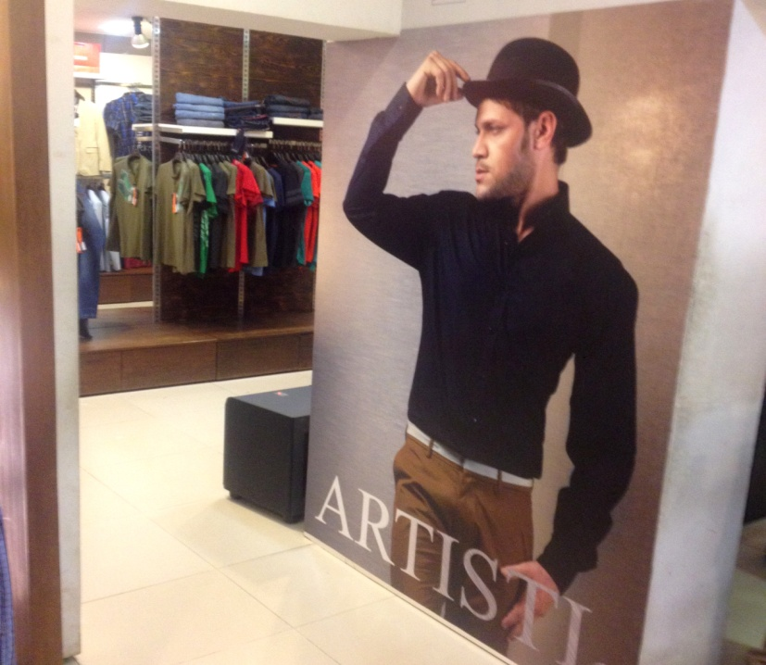

3.5.6 Branding by Visual Merchandising:
ARTISTI has their own expert visual merchandising team & the visual merchandising team is always trying to Branding by using the exclusive products of ARTISTI.
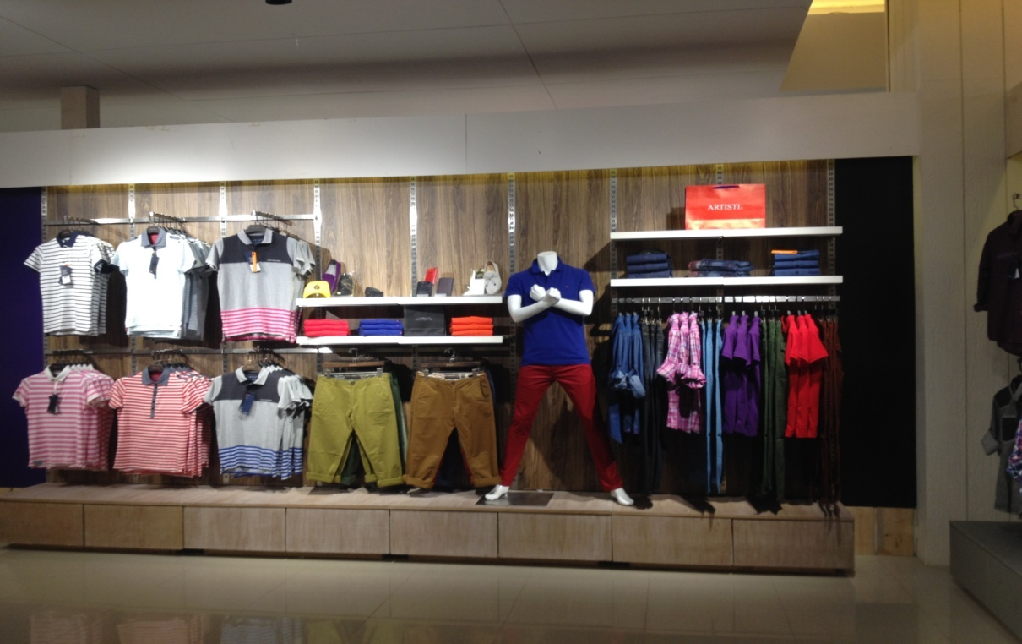
ARTISTI strongly believed that, A True brand is built upon trust & a trust that can’t be earned over night. So ARTISTI is always serious about their quality & their brand position.

3.6 Market Size of ARTISTI COLLECTION

Table-1: Percentage of market share
Name of the Company | % of Market Share
ARONG | 37.09 %
ARTISTI | 20.6%
ECSTASY | 21.4%
CATS EYE | 10.01%
INFINITY | 10.2%
OTHERS | 1.09%
Source: BGMEA

3.7 Occasion wise sales
Occasions | 2013 | 2014 | % of growth
WINTER BLAST PROMOTION | 12,050,200.00 | 15,080,300.00 | 25.14%
VALENTINE PROMOTION | 16,520,150.00 | 2,02,50169.00 | 22.57%
BAISHAKH PROMOTION | 17,520,500.00 | 23,550,000.00 | 34.41%
EID-UL- ADHA | 34,150,869.00 | 41,000,000.00 | 20.05%
EID-UL- FITRE | 28,050,000.00 | 35,000,000.00 | 24.77%

Sources: Official documents Table-2: Occasion wise sales in 2013 to 2014

3.7 Comparison of Sales in 2013 to 2014
Increasing revenue is the ultimate focus of both Marketing and Sales departments. Though the Marketing & Sales are two different aspects of business but they are so complimentary to each-other that people often don’t realize the difference between the two. Indeed, in small organizations, the same people typically perform both sales and marketing tasks. The process of identifying, anticipating and then meeting the needs/requirements of consumers in order to make a profit is the Marketing. In the contrary, selling involves persuading customers to purchase those products/services that they are looking for. These almost two different but unified features are simultaneously being looked after by the department of Marketing & Sales of ARTISTI with their small scale structure. In reality the tasks of Marketing & Sales department are massive and sturdy, proficient, enthusiastic, innovative and forerunner team is essential to manage those tasks which ARTISTI is not fully contented.
Table – 3: Sales in 2013 to 2014
MONTH | 2013 | 2014 | % CHANGE
JANUARY | 11,160,210.00 | 15,030,160.00 | 34.67%
FEBRUARY | 16,520,305.00 | 18,050,200.00 | 9.26%
MARCH | 14,500,600.00 | 20,002,830.00 | 37.94%
APRIL | 17,500,100.00 | 22,000,550.00 | 25.71%
MAY | 18,000,000.00 | 19,570,889.00 | 8.72%
JUNE | 13,000,950.00 | 16,500,000.00 | 26.91%
JULY | 34,000,000.00 | 41,000,000.00 | 20.58%
AUGUST | 11,080,115.00 | 16,500,000.00 | 26.91%
SEPTEMBER | 15,500,100.00 | 20,500,000.00 | 32.25%
OCTOBER | 22,050,900.00 | 24,000,000.00 | 8.83%
NOVEMBER | 14,000,000.00 | 19,030,000.00 | 35.92%
DECEMBER | 12,000,950.00 | 15,070,800.00 | 25.58%
TOTAL | 199,120,000.00 | 247,050,000.00 | 24%

A systematic approach to address the Marketing and Sales issues felt essential resulting which a venture to constitute a SOP has been under taken. It is believed that following these sales teams would definitely produce result in the mentioned field.

3.8 Sales in Foreign Market

JANUARY | FEBRUARY | MARCH | TOTAL | RATE | AMOUNT
550 | 600 | 400 | 1550 | 3,495.00 | 5,417,250.00
450 | 300 | 200 | 950 | 1,495.00 | 1,420,250.00
700 | 400 | 370 | 1470 | 1,795.00 | 2,638,650.00
450 | 400 | 370 | 1220 | 1,295.00 | 1,579,900.00
2120 | 1700 | 1340 | 5190 |  | 1,156,050.00

At this point of time ARTISTI has extended its boundary up to Singapore. A worldwide exposure through extension of services for the class people across the globe is not a ‘wild dream’ anymore. We are looking forward to go global through our inimitable designs and supreme quality.

SWOT Analysis

4.1 SWOT Analysis
SWOT analysis is a simple framework for generating strategic alternatives from a situation analysis. It is applicable to either the corporate level or the business unit level and frequently appears in marketing plans. SWOT (sometimes referred to as TOWS) stands for Strengths, Weaknesses, Opportunities, and Threats. The SWOT framework was described in the late 1960's by Edmund P. Learned, C. Roland Christiansen, Kenneth Andrews, and William D. Guth in Business Policy, Text and Cases (Homewood, IL: Irwin, 1969). The General Electric Growth Council used this form of analysis in the 1980's. Because it concentrates on the issues that potentially have the most impact, the SWOT analysis is useful when a very limited amount of time is available to address a complex strategic situation.
4.1.1 Strengths:
The strengths of Artisti are its incontestable and uncompromising Quality, Supreme Craftsmanship, Infrequent Design, World Class Design Studio and its R&D Team. Little elaboration of our strengths is:
- Incontestable and Uncompromising Quality: Artisti is known by its name as the Best Brand in the sphere of Men’s Wear in Bangladesh for its quality products. It did not just happened; rather a dedicated team inexorably worked years together to build these reputation. We strongly believe in QUALITY and we shall continue to produce QUALITY PRODUCTS for the Fashion Loving Class People. We follow and strictly maintain the One & Only Policy which is: ‘NO COMPROMISE WITH ANY QUALITY ISSUES IN ARTISTI PRODUCT’. Artisti uses 100% Linen fabric originated from Europe, 100% Egyptian cotton, supreme quality Denim, Twill, Corduroy and Knit fabrics from Japan, Thailand, China and India for product line.

- Craftsmanship: Craftsmanship is the quality of the work, passion for betterment and experience. Artisti believes in all three points those have been mentioned above and persistently following those to achieve the best results. And, proudly we can say that the Artisti is completely successful.

- Value Addition: Artisti is master in the fields of value addition through its unique Craftsmanship, Wash, Spray and Dyeing process. In these fields Artisti is capable of competing any international leading brand.

- Multiplicity in Products: Artisti holds diversity in product line and it is complete with all categories, all weather and all ranges of Men’s wear starting from the formal to casual and even to occasional attires.

- Infrequent Designs: Artisti produces designs those are not only unique in nature but also trendy and absolute for the fashion loving elites of the society.
- World Class Design Studio: Artisti has a world class design studio complemented by the renowned designers from Bangladesh, India, China and Thailand to create our fashion unique & trendy. Most importantly, keeping in mind the latest trends of world fashion we design our attires to meet & match the expectations of our valued users.

- Research & Development (R&D): The strong Research & Development Team of Artisti studies the world leading brands, analyzes latest trends, does the market research and relentlessly monitors the sales to determine the fast/slow moving merchandise and advices/suggests the Design Development Team to go for designs those are the perfect match for the latest trends.

- Grand Showrooms: In Bangladesh Artisti is maintaining more than 50,000 square feet space for its retail operations which is an issue of envy for other brands. We are managing two showrooms in Singapore; The Centre point & 246 Serangoon Road.

4.1.2 Weakness:

- Artisti was established as a Men’s Brand and we continued for eighteen years depriving the ladies of our society. We are seriously thinking to incorporate ladies wear shortly.
- Salary proportion is not good.
- Supply chain is not up to the mark.
- Financial& marketing aspects get little attention.
- Sometimes companies are not provided full satisfy services to consumer.
- Insufficient legal services for the company.
4.1.3 Opportunities:

- Now a day the company given many chances of them who are unemployed and search job.
- Day by day the company becomes developed & forwarded.
- Service quality is better than others company.
- Our training quality is modern & any situation are easily face.
- To be a renowned brand internationally very soon.
- Great career opportunity

4.1.4 Threats
- Future competition from already established market participation.
- Challenger in the market are Arong Ecstasy, Infinity
- In present& current political situation is big threat for this company.
- Job satisfaction is not good enough so some skilled employee change the job.

Findings, Recommendations & Conclusion

5.1 Findings:
Problem definition is first step for solving any sort of market related problem. If the problem can be identified then the solution of the same problems becomes very easy then it is matterof time only.
- To solvency dimension of ARTISTI is not so strong.
- The operating performance of ARTISTI IS Good.
- Working capital of ARTISTI is not satisfactory.
- At least I can conclude that overall performance of the company is satisfactory.
- Now a day a company given many chances of them who are unemployed & search job.
- There are so many people whose are interested to work with ARTISTI.

5.2 Recommendations:
- Motivating the Employees to giving a best Service.
- Introduction of production planning.
- Supply chain Refurnish.
- Improve the advertising activities.
- Modernization of marketing activities.

5.3 Conclusion:
We have stepped ahead to serve our respected customers and at the same times we would expect that you will extend your hand of cooperation towards ARTISTI.

Bibliography

Books:
- Kotler Philip, Armstrong Garry, ”Principles of Marketing” 13th Edition
- Kotler Philip, Keller lane kevin“Marketing Management” 13th Edition
- Keller Lane kevin ”Strategic Brand Management” 3rd addition
- Aaker David A “Consumer Behavior” 6th Edition
Website Sites:
- www.google.com
- www.myartisti.com
- www.ask.com
Others:
- Annual report of 2014 of ARTISTI collection.
- Prospectus
- E. brochure

